Mid-Term Examination

CSC600 Advanced Programming
(70 points)

Write a JavaFX program that allows users to perform maintenance for a given set of names.
- When the load button is pressed, read a set of names, preferably 10 or more from an initialized array.
- Display the array into the combo Box or list Box.
- The add button allows the user to add to the existing list.
- Remove will delete a name from the list.
- Allow the user to highlight or select one or more names from the list box. When the user presses the select button display a dialog box indicating the names selected.
- The reset button restores the listbox from the original array.
- The exit button terminates the button.

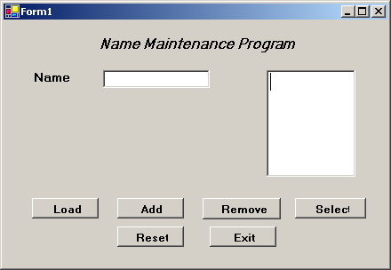

Submission: Provide IDEs project and source files for testing in a single zip file .

